TS7960 – DRIVER PER MOTORI C.C. + ESP32
ll driver TS7960 per motori da 43A utilizza due mosfet BTS7960 per pilotare motori con assorbimento fno a 43A.
Il driver e protetto contro il surriscaldamento, la sovracorrente, la sovratemperatura e il corto circuito.
Il pilotaggio dei mosfet BTS7960 è effettuato tramite un 74HC244 in modo da isolare il circuito di controllo dal circuito di potenza.
Caratteristiche:
- Tensione di alimentazione da 6Vcc a 27Vcc
- Tensione di controllo da 3,3Vcc a 5Vcc
- Corrente massima di lavoro 43A a 24Vcc

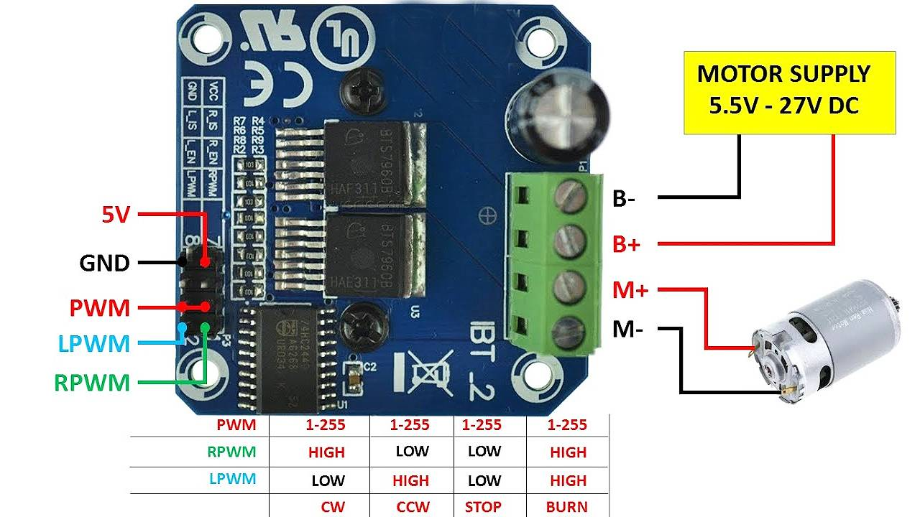

Applicazioni
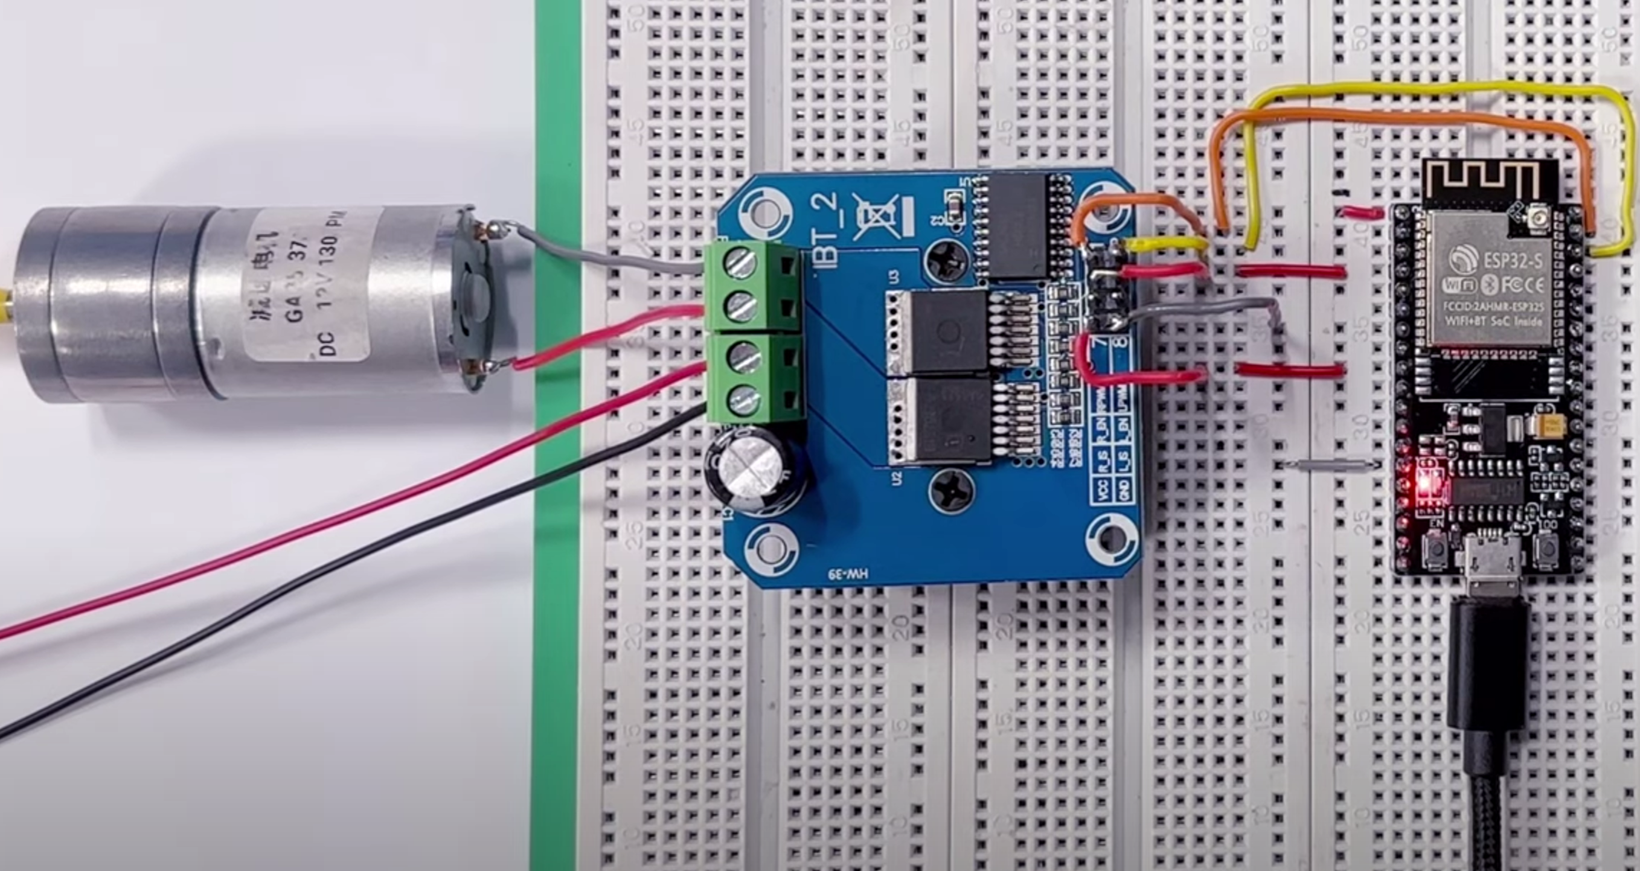
12 V
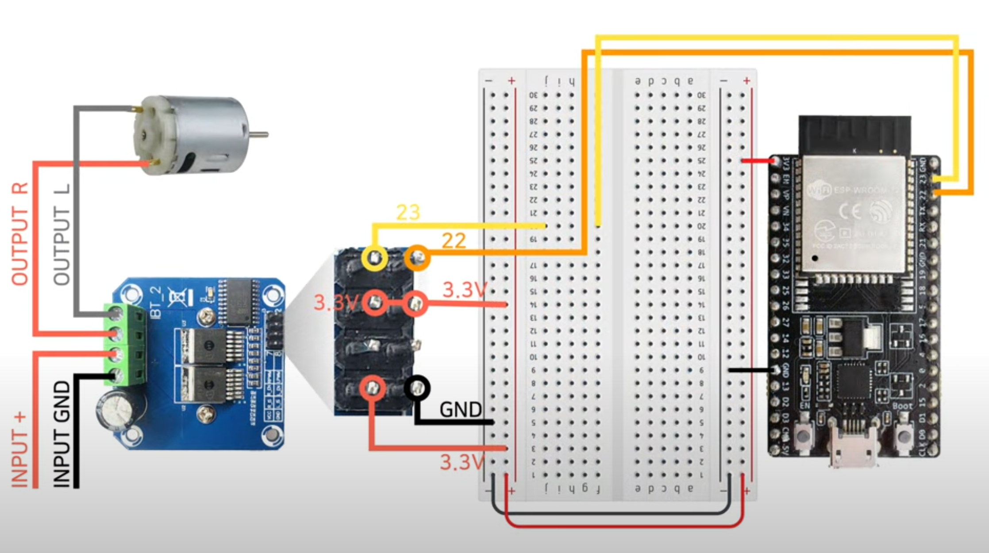
12 V

Codice

const int motor_R = 9;
const int motor_L = 10;

void setup() {
}

void loop() {
analogWrite(motor_L, 0);
delay(500);

for(int i=0; i<255; i++) {
analogWrite(motor_R, i);
delay(30);
}

analogWrite(motor_R, 0);
delay(500);

for(int i=0; i<255; i++) {
analogWrite(motor_L, i);
delay(30);
}
}

/////////////////////////////////////////////////////////////////////////////////////////////////////////////////////////////////

int RPWM=5;
int LPWM=6;
// timer 0
int L_EN=7;
int R_EN=8;
void setup() {
// put your setup code here, to run once:
for(int i=5;i<9;i++){
pinMode(i,OUTPUT);
}
for(int i=5;i<9;i++){
digitalWrite(i,LOW);
}
delay(1000);
Serial.begin(9600);
}
void loop() {
// put your main code here, to run repeatedly:
Serial.println("EN High");
digitalWrite(R_EN,HIGH);
digitalWrite(L_EN,HIGH);
delay(1000);
for(int i=0;i<256;i++){
analogWrite(RPWM,i);
// analogWrite(LPWM,255-i);
delay(100);
}
delay(500);
for(int i=255;i>0;i--){
analogWrite(RPWM,i);
// analogWrite(LPWM,255-i);
delay(100);
}
delay(500);
Serial.println("EN LOW");
digitalWrite(R_EN,LOW);
digitalWrite(L_EN,LOW);
delay(1000);
for(int i=0;i<256;i++){
analogWrite(RPWM,i);
delay(100);
}
delay(500);
for(int i=255;i>0;i--){
analogWrite(RPWM,i);
delay(100);
}
delay(500);
}
The PWM Frequency on the arduino UNO Atmega328p - Timer0 is 970Hz ,
This is a low PWM Frequency , in the next step we want to increase PWM Frequency to get a more smoothly control of the motor.
Arduino Uno atmega 328p MCU has 3 timers , Time0,,Time2 8 Bit and Time1 16Bit .
Timer0 is connected to pin D5 , D6 , we want to increase the frequency "More smoothly control "
Note That Timer0 is control the (delay , millis ) on the arduino , so any change on the prescale of this timer will change the delay and millis time .
int RPWM=5;
int LPWM=6;
int L_EN=7;
int R_EN=8;
void setPWMfrequency(int freq){
TCCR0B = TCCR0B & 0b11111000 | freq ;
}
void MotorActiveStatus(char Side,boolean s){
boolean state=s;
if(Side=='R'){
digitalWrite(R_EN,s);
}
if(Side=='L'){
digitalWrite(L_EN,s);
}
}
void setMotor(char side,byte pwm){
if(side=='R'){
analogWrite(RPWM,pwm);
}
if(side=='L'){
analogWrite(LPWM,pwm);
}
}
void closeMotor(char side){
if(side=='R'){
digitalWrite(RPWM,LOW);
}
if(side=='L'){
digitalWrite(LPWM,LOW);
}
}
void setup() {
// put your setup code here, to run once:
setPWMfrequency(0x02);// timer 0 , 3.92KHz
for(int i=5;i<9;i++){
pinMode(i,OUTPUT);
}
for(int i=5;i<9;i++){
digitalWrite(i,LOW);
}
delay(1000);
MotorActiveStatus('R',true);
MotorActiveStatus('L',true);
Serial.begin(9600);
}
void loop() {
// put your main code here, to run repeatedly:
for(int i=0;i<256;i++){
setMotor('R',i);
delay(500);
}
delay(1000);
closeMotor('R');
delay(1000);
for(int i=0;i<256;i++){
setMotor('L',i);
delay(500);
}
delay(1000);
closeMotor('L');
delay(1000);
}
if we want to use this code with another timer " timer 2 " just change D5 , D6 To pin D3 , D11 Respectively
int RPWM=3;
int LPWM=11;
int L_EN=7;
int R_EN=8;
void setPWMfrequency(int freq){
TCCR2B = TCCR2B & 0b11111000 | freq ;
}
void MotorActiveStatus(char Side,boolean s){
boolean state=s;
if(Side=='R'){
digitalWrite(R_EN,s);
}
if(Side=='L'){
digitalWrite(L_EN,s);
}
}
void setMotor(char side,byte pwm){
if(side=='R'){
analogWrite(RPWM,pwm);
}
if(side=='L'){
analogWrite(LPWM,pwm);
}
}
void closeMotor(char side){
if(side=='R'){
digitalWrite(RPWM,LOW);
}
if(side=='L'){
digitalWrite(LPWM,LOW);
}
}
void setup() {
// put your setup code here, to run once:
setPWMfrequency(0x02);// timer 2 , 3.92KHz
for(int i=5;i<9;i++){
pinMode(i,OUTPUT);
}
for(int i=5;i<9;i++){
digitalWrite(i,LOW);
}
delay(1000);
MotorActiveStatus('R',true);
MotorActiveStatus('L',true);
Serial.begin(9600);
}
void loop() {
// put your main code here, to run repeatedly:
for(int i=0;i<256;i++){
setMotor('R',i);
delay(50);
}
delay(500);
closeMotor('R');
delay(1000);
for(int i=0;i<256;i++){
setMotor('L',i);
delay(50);
}
delay(500);
closeMotor('L');
delay(1000);
}

